ET Programming Header

1 MISO
2 VCC33
3 SCK
4 MOSI
5 RESET
6 GND
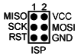

AVR ISP MK 2:

